TEXT VIEW

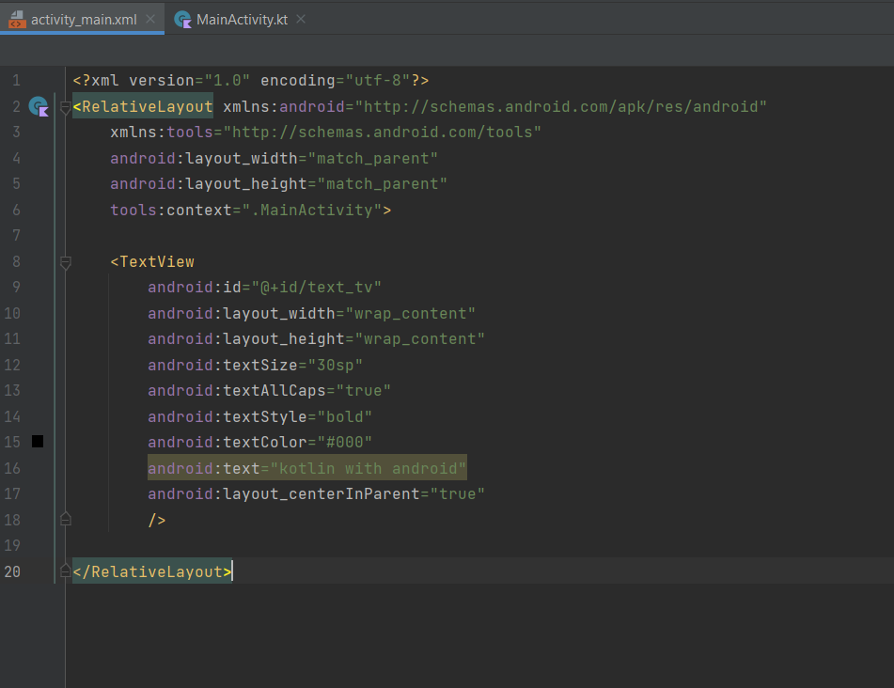

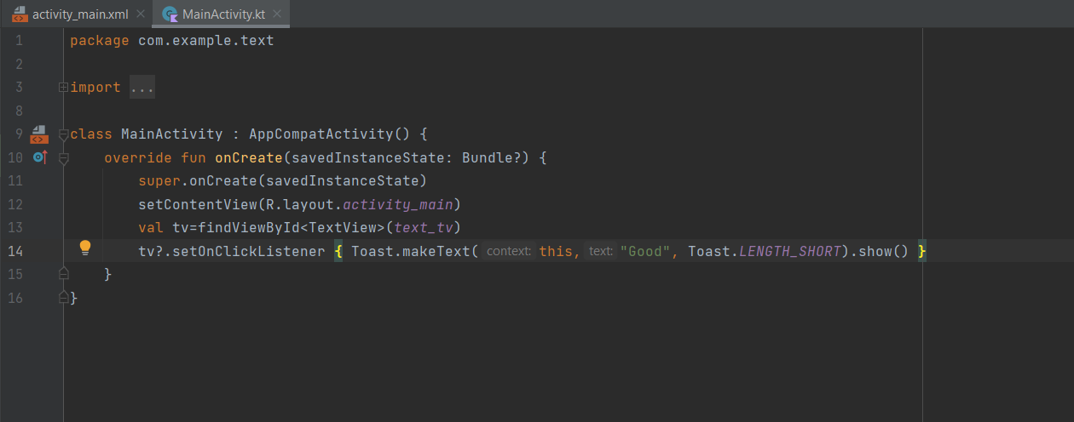

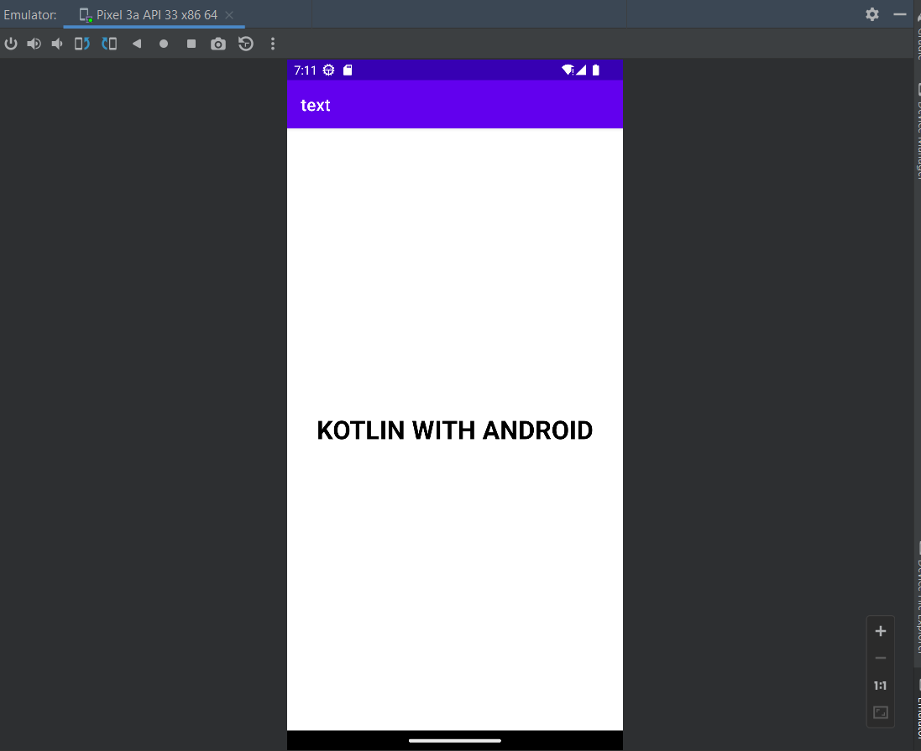

EDIT TEXT

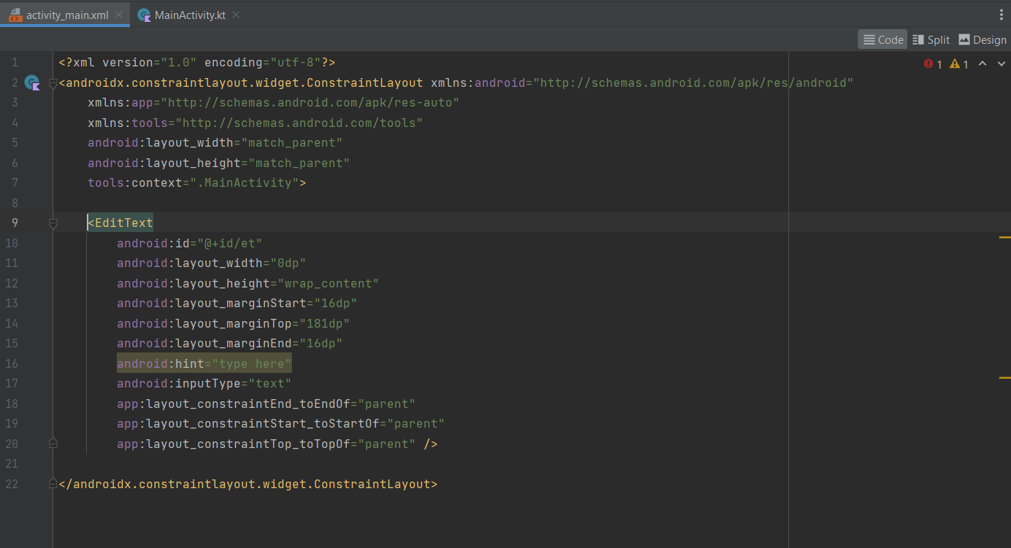

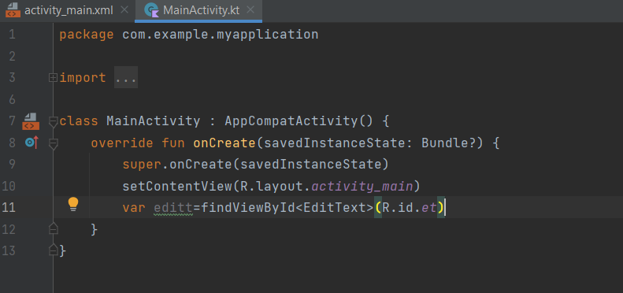

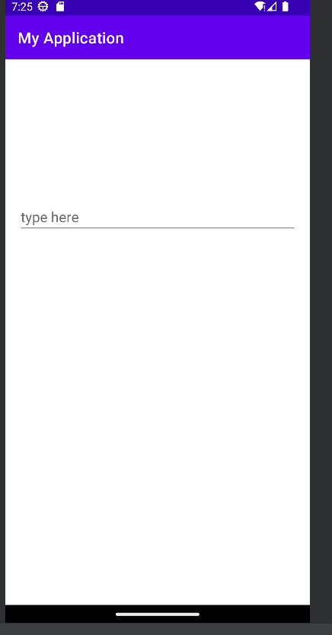

BUTTON

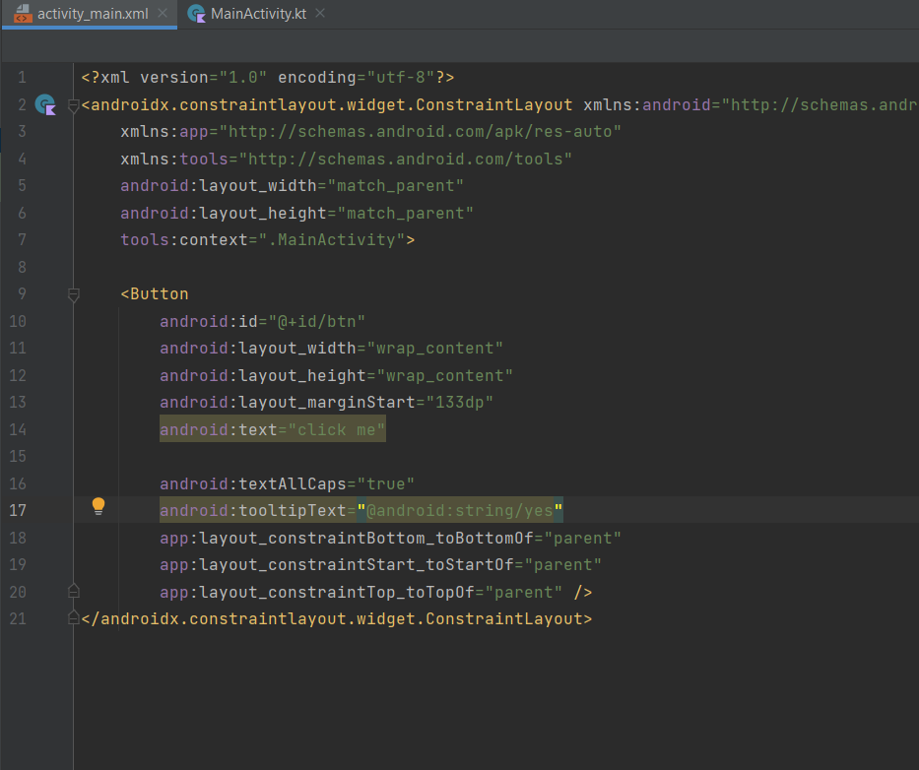

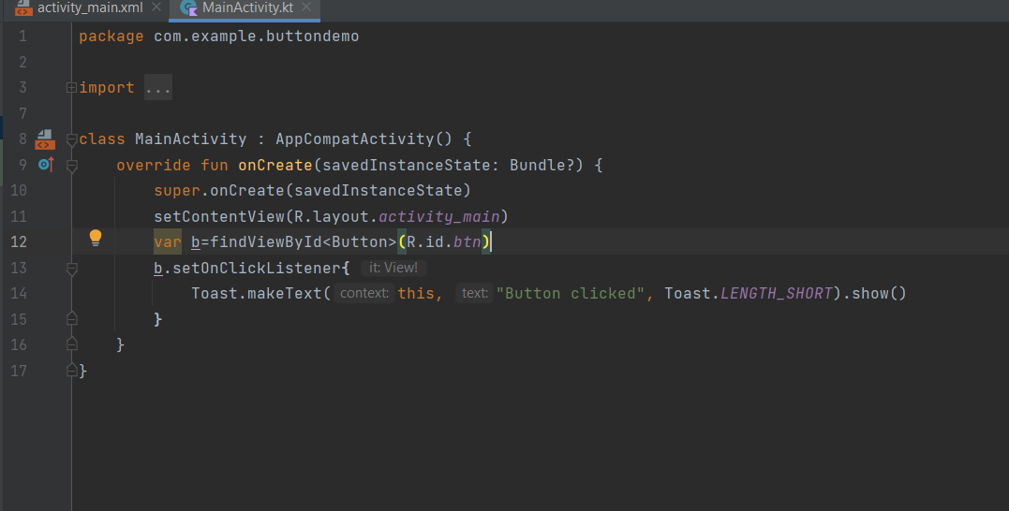

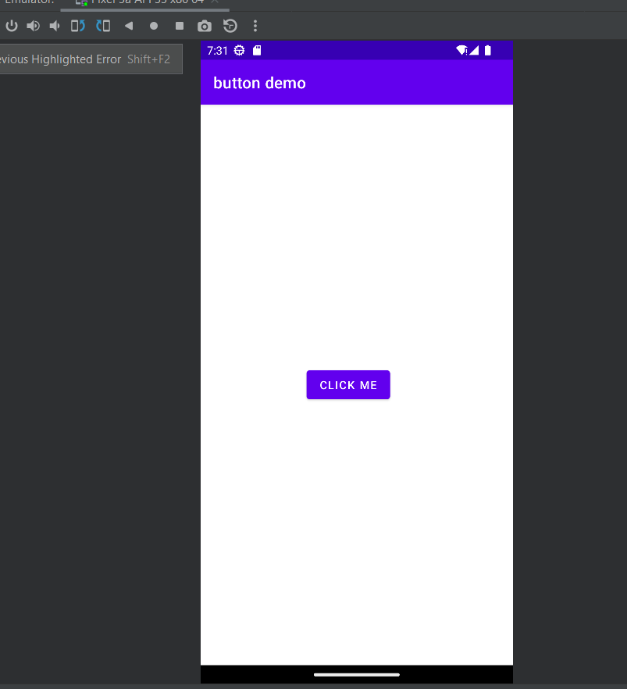

IMAGE VIEW

IMAGE BUTTON

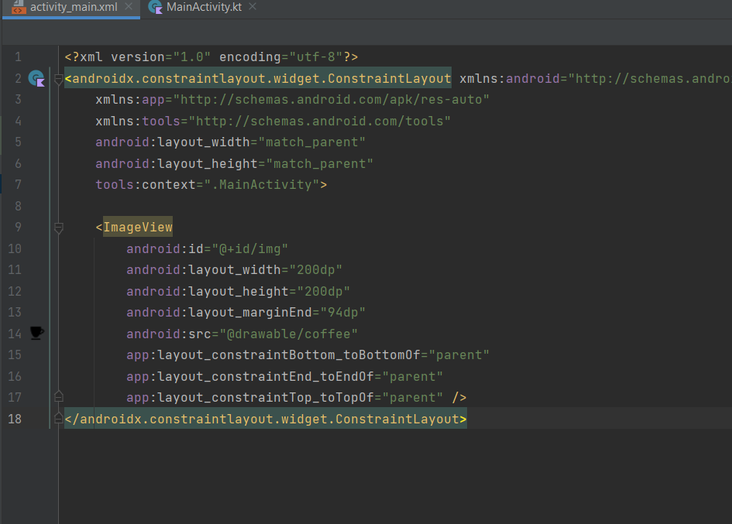

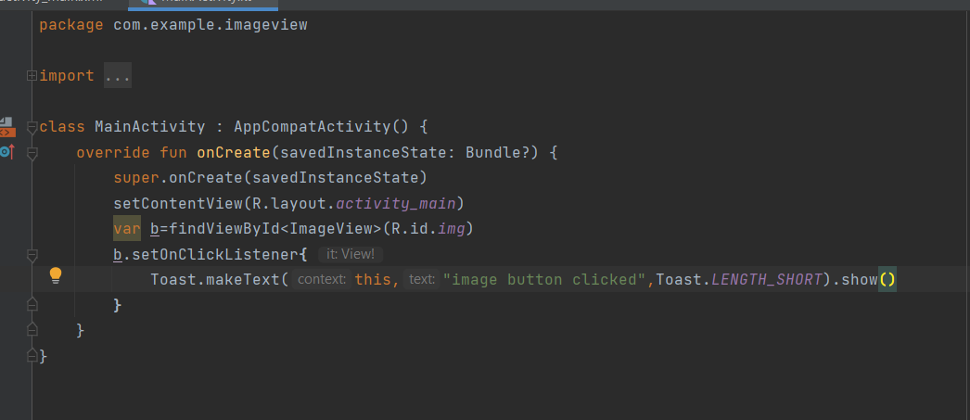

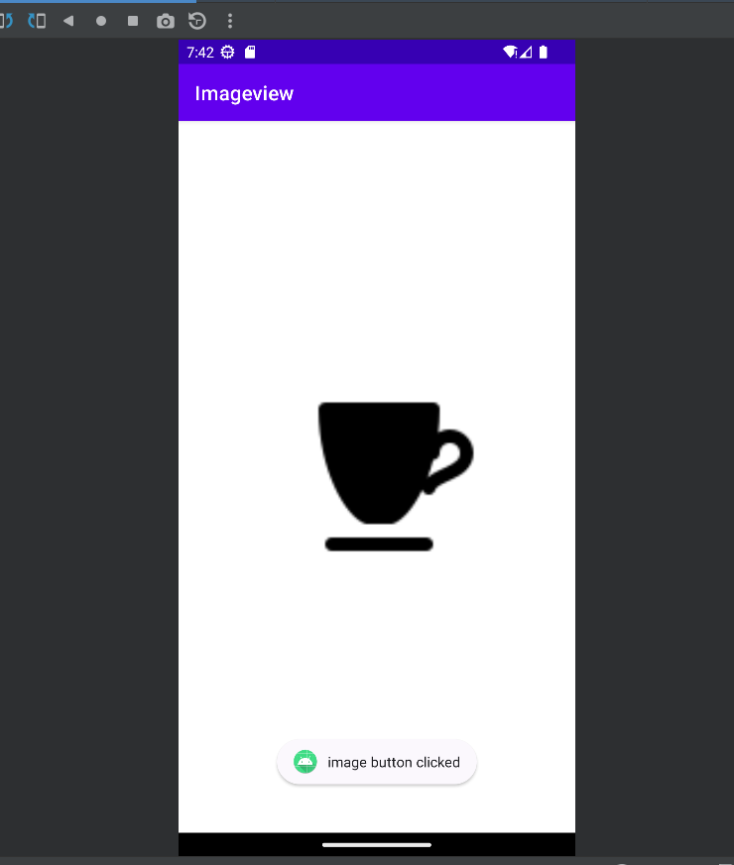

RADIO BUTTON

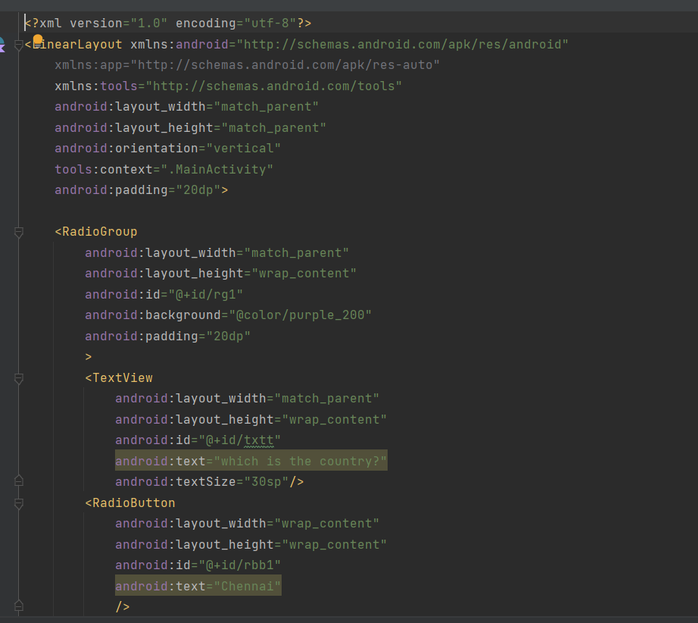

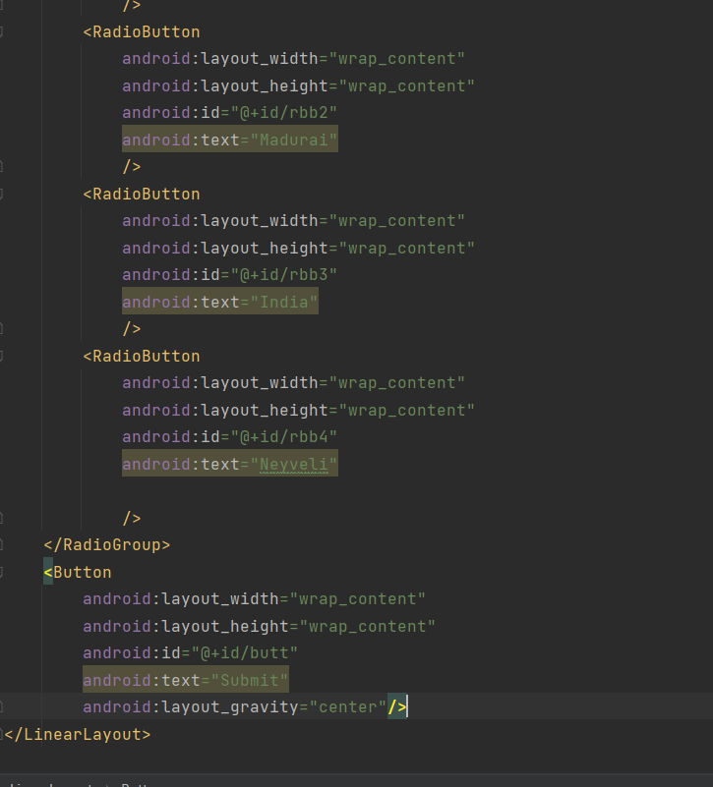

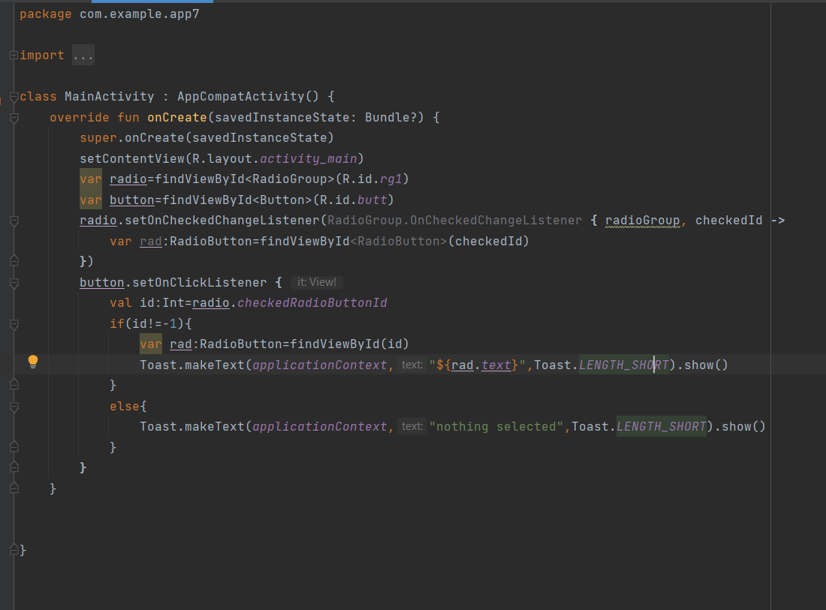

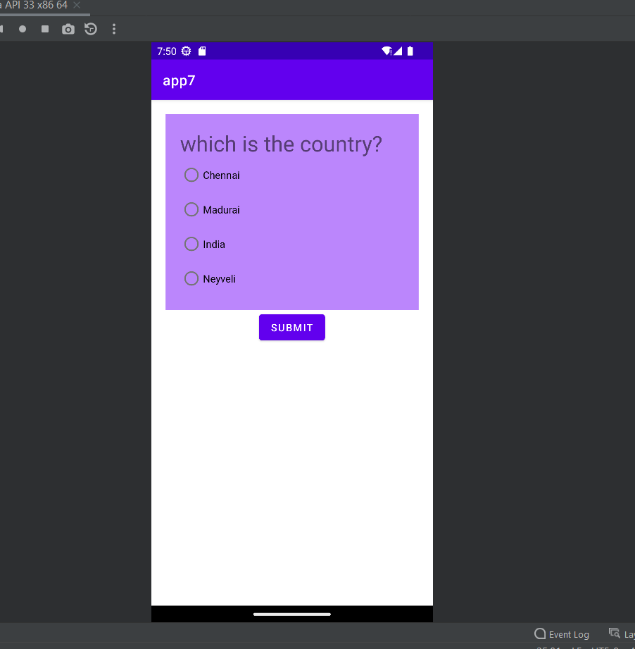

TEXT TO SPEECH

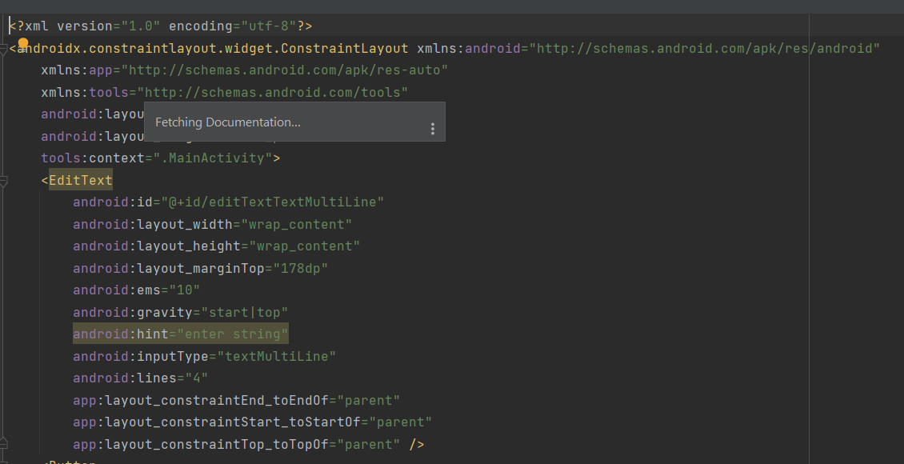

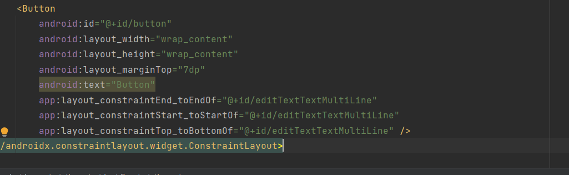

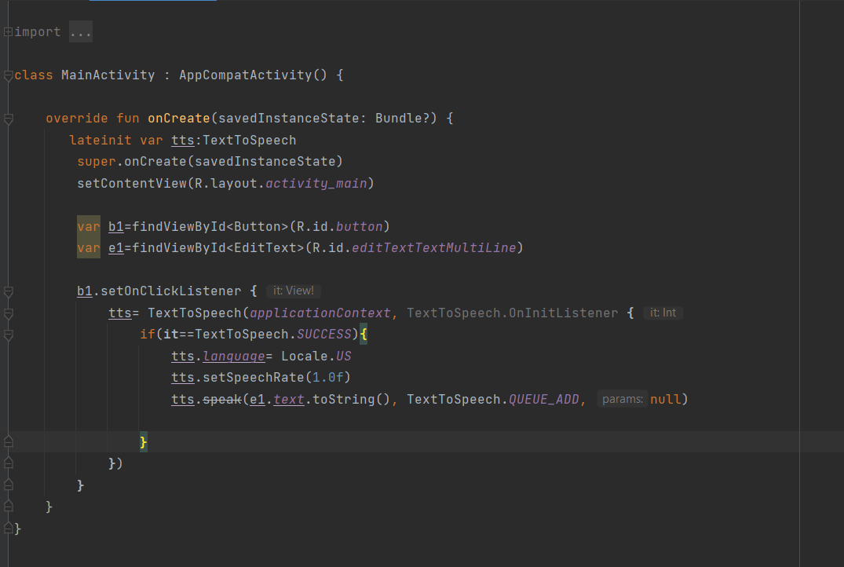

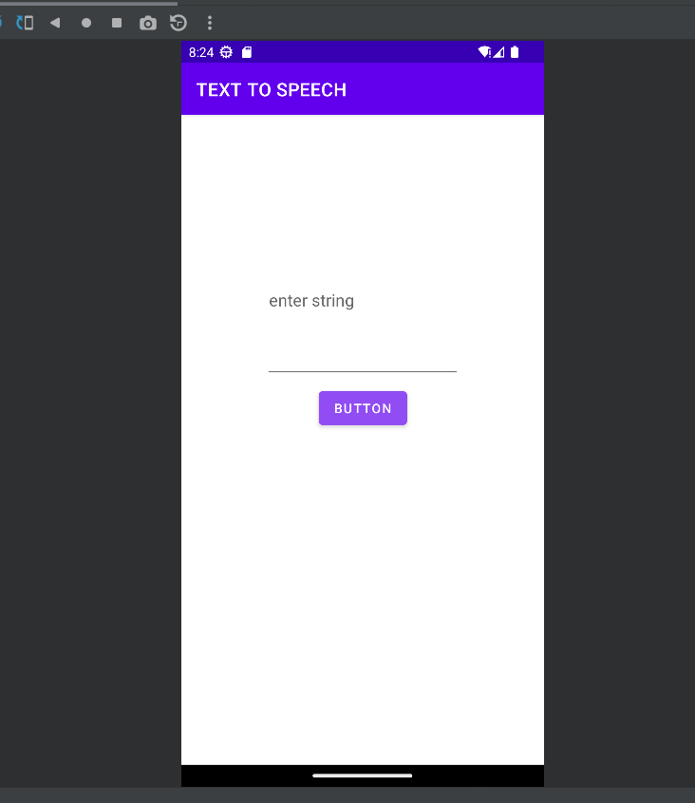

CALCULATOR

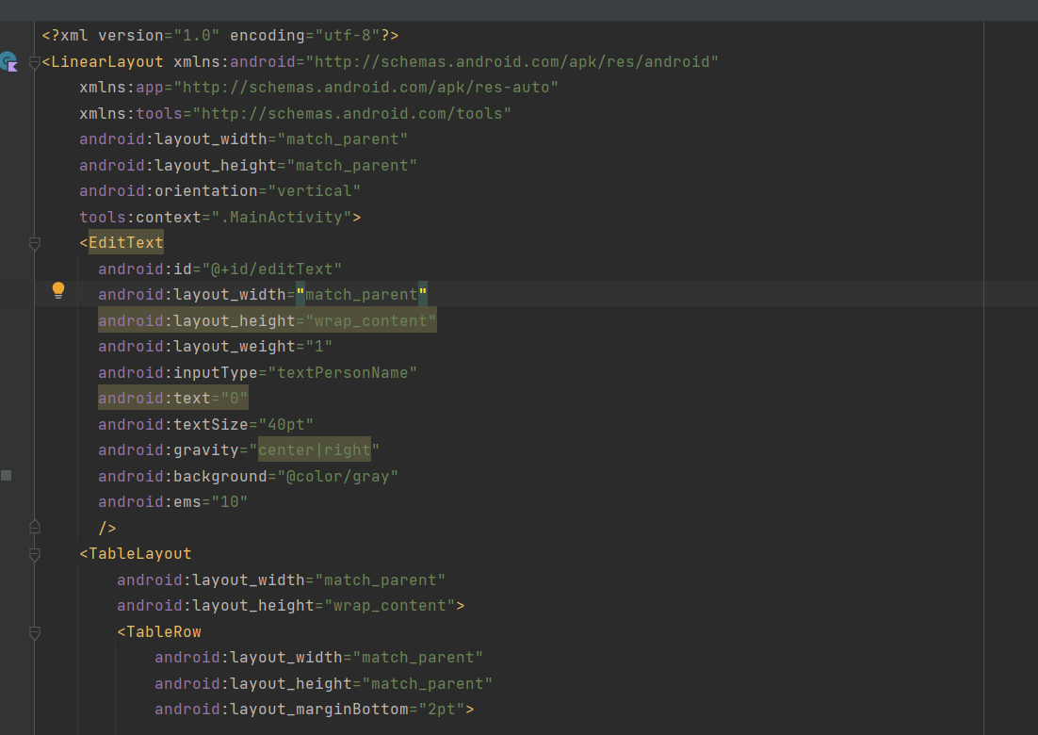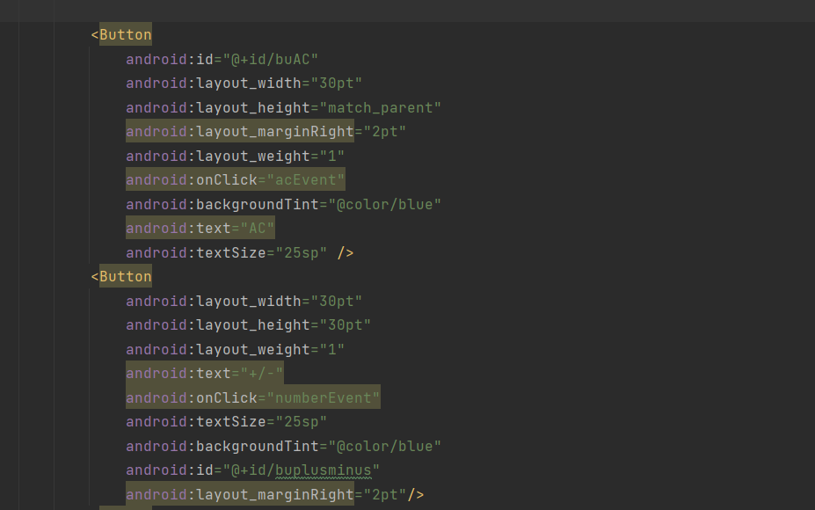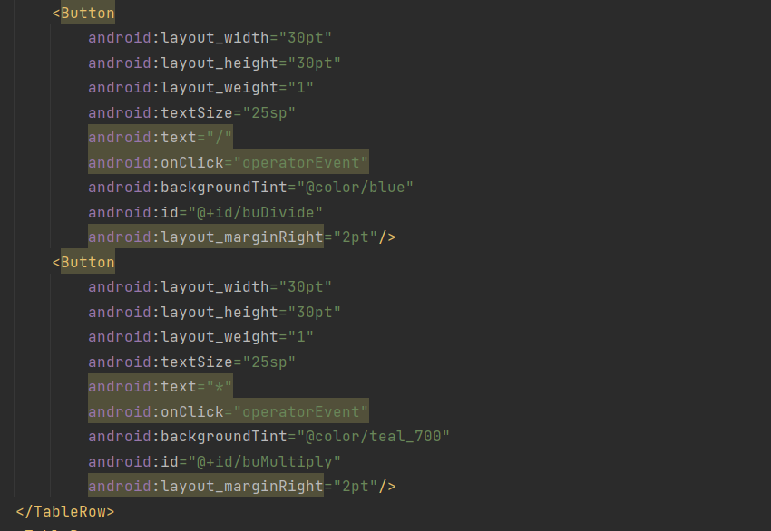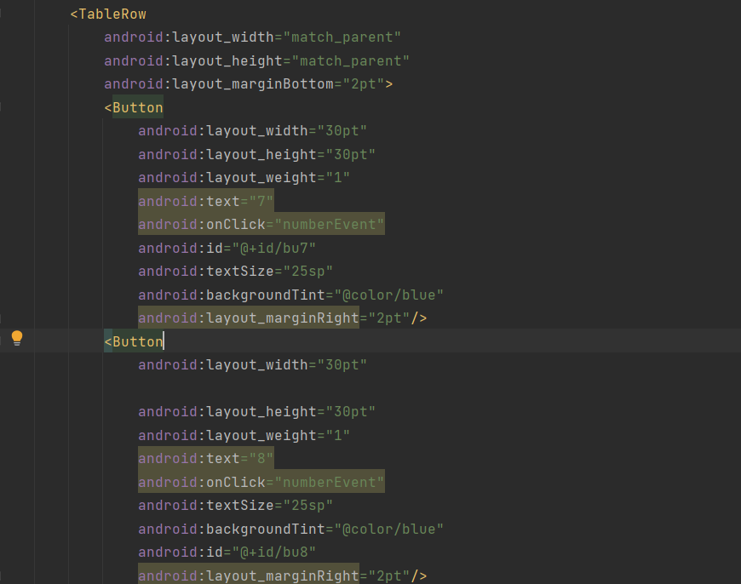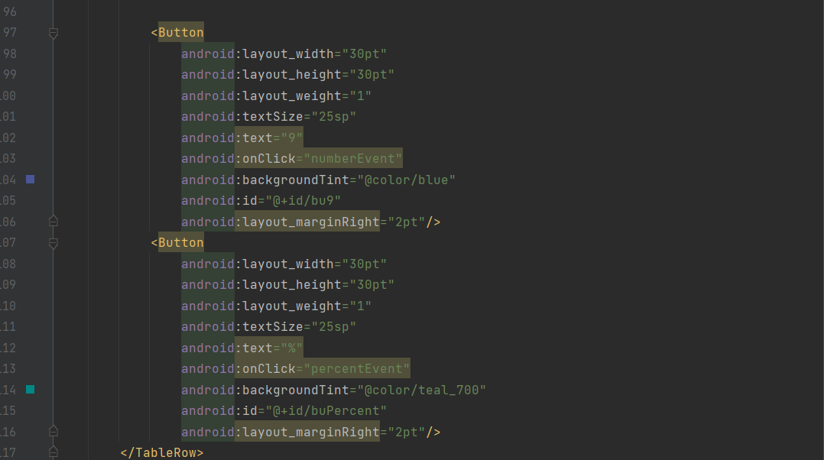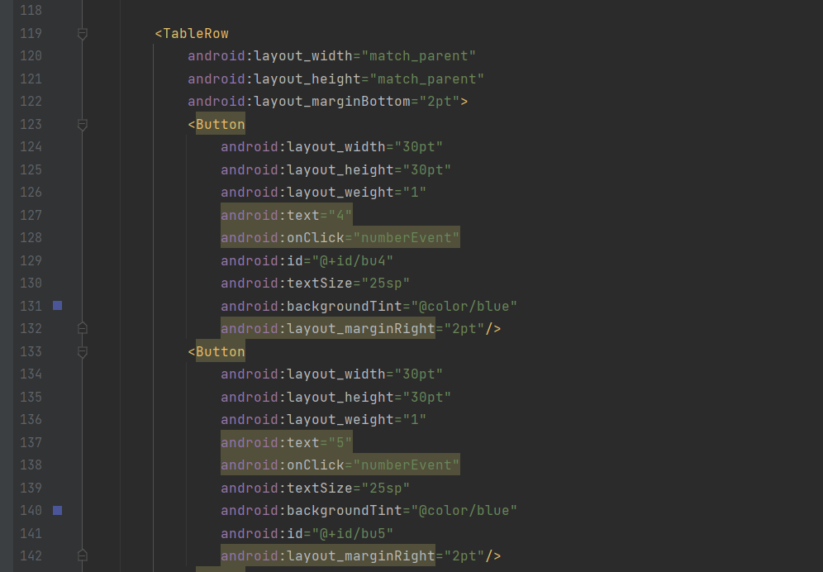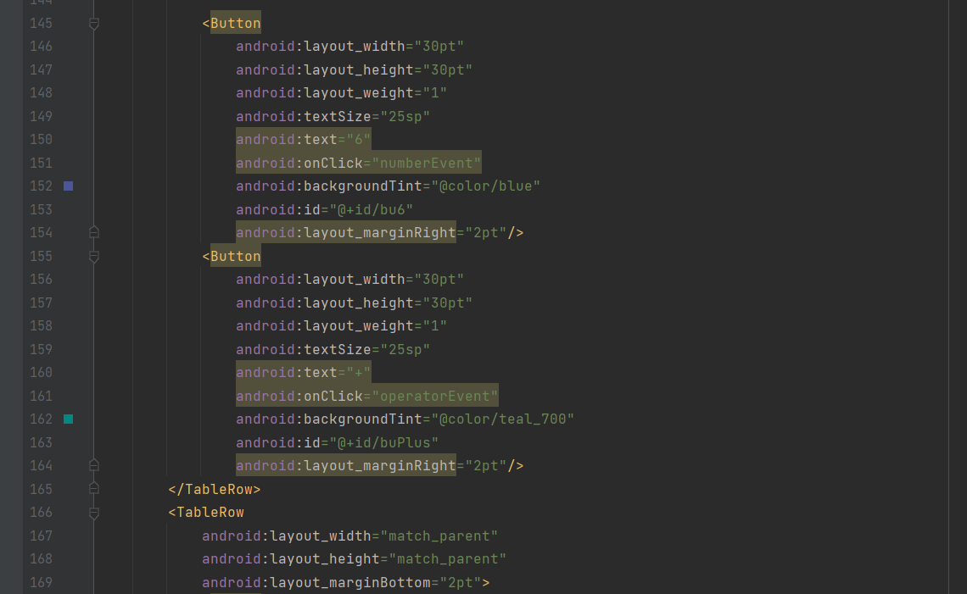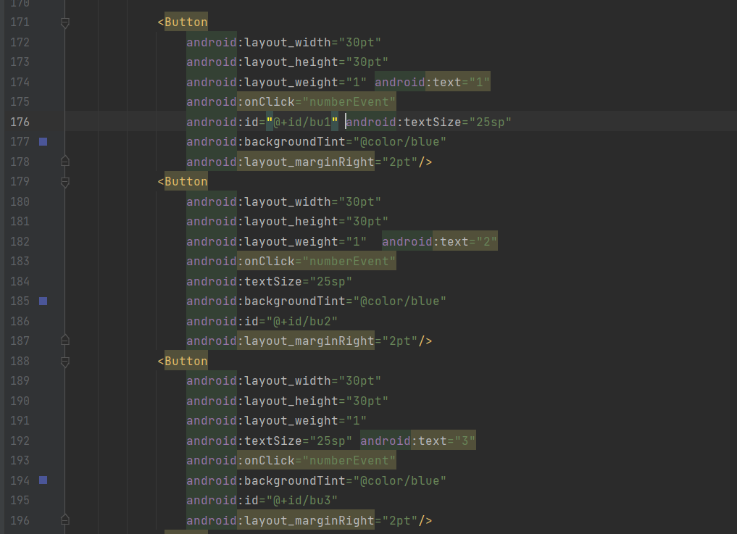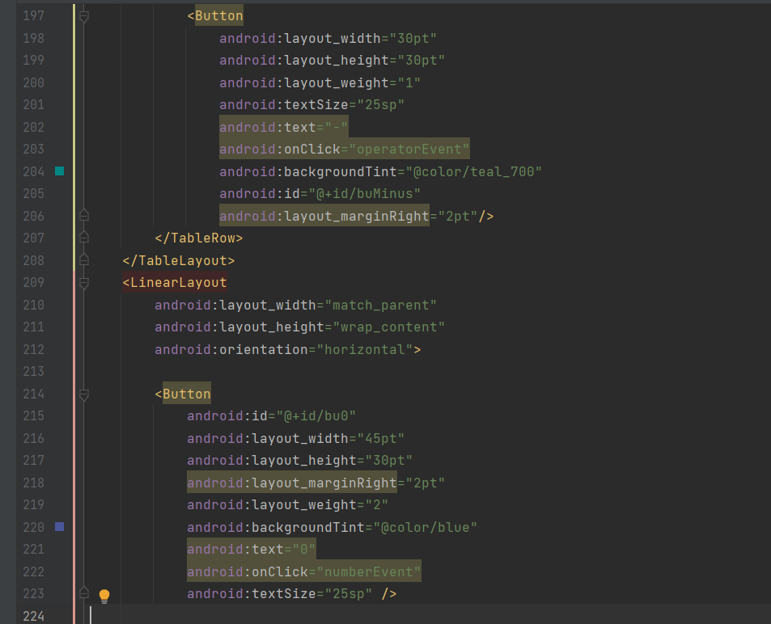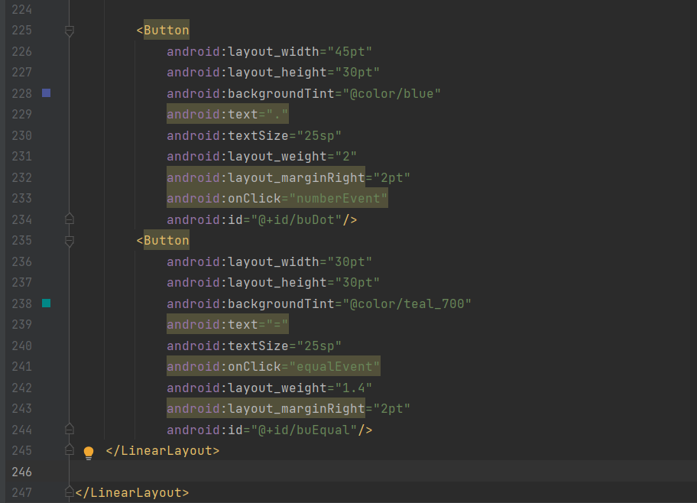

package com.example.calculatorapp  
  
import androidx.appcompat.app.AppCompatActivity  
import android.os.Bundle  
import android.view.View  
import android.widget.Button  
import android.widget.EditText  
  
class MainActivity : AppCompatActivity() {  
 var isNewOp=true  
 var oldnumber=""  
 var op="+"  
 lateinit var editText:EditText  
 override fun onCreate(savedInstanceState: Bundle?) {  
 super.onCreate(savedInstanceState)  
 setContentView(R.layout.*activity_main*)  
 }  
 fun numberEvent(view: View) {  
  
 editText=findViewById<EditText>(R.id.*editText*)  
 if(isNewOp)  
 editText.setText("")  
 isNewOp=false  
 var bu1=findViewById<Button>(R.id.*bu1*)  
 var bu2=findViewById<Button>(R.id.*bu2*)  
 var bu3=findViewById<Button>(R.id.*bu3*)  
 var bu4=findViewById<Button>(R.id.*bu4*)  
 var bu5=findViewById<Button>(R.id.*bu5*)  
 var bu6=findViewById<Button>(R.id.*bu6*)  
 var bu7=findViewById<Button>(R.id.*bu7*)  
 var bu8=findViewById<Button>(R.id.*bu8*)  
 var bu9=findViewById<Button>(R.id.*bu9*)  
 var bu0=findViewById<Button>(R.id.*bu0*)  
 var buDot=findViewById<Button>(R.id.*buDot*)  
 var buplusminus=findViewById<Button>(R.id.*buplusminus*)  
 var buclick=editText.*text*.toString()  
 var buselect=view as Button  
 when(buselect.*id*){  
 bu1.*id* -> {buclick+="1"}  
 bu2.*id*->{buclick+="2"}  
 bu3.*id*->{buclick+="3"}  
 bu4.*id*->{buclick+="4"}  
 bu5.*id*->{buclick+="5"}  
 bu6.*id*->{buclick+="6"}  
 bu7.*id*->{buclick+="7"}  
 bu8.*id*->{buclick+="8"}  
 bu9.*id*->{buclick+="9"}  
 bu0.*id*->{buclick+="0"}  
 buDot.*id*->{buclick+="."}  
 buplusminus.*id*->{  
 if (buclick> 0.toString())  
 buclick="-$buclick"  
 else{  
 val change= (buclick.*toInt*())*-1  
 buclick="$change"  
 }  
 }  
 }  
 editText.setText(buclick)  
 }  
  
 fun operatorEvent(view: View) {  
 isNewOp=true  
 editText=findViewById<EditText>(R.id.*editText*)  
 oldnumber=editText.*text*.toString()  
 var buPlus=findViewById<Button>(R.id.*buPlus*)  
 var buMinus=findViewById<Button>(R.id.*buMinus*)  
 var buMultiply=findViewById<Button>(R.id.*buMultiply*)  
 var buDivide=findViewById<Button>(R.id.*buDivide*)  
 *println*(oldnumber)  
 var buselect=view as Button  
 when(buselect.*id*) {  
 buMultiply.*id* -> {  
 op = "*"  
 }  
 buDivide.*id* -> {  
 op = "/"  
 }  
 buMinus.*id* -> {  
 op = "-"  
 }  
 buPlus.*id* -> {  
 op = "+"  
 }  
 }  
 }  
  
 fun equalEvent(view: View) {  
 editText=findViewById<EditText>(R.id.*editText*)  
 var newnumber=editText.*text*.toString()  
 *println*(newnumber)  
 var result=0.0  
 when(op){  
 "+"->{result=newnumber.*toDouble*()+oldnumber.*toDouble*()}  
 "-"->{result=oldnumber.*toDouble*()-newnumber.*toDouble*()}  
 "/"->{result=oldnumber.*toDouble*()/newnumber.*toDouble*()}  
 "*"->{result=newnumber.*toDouble*()*oldnumber.*toDouble*()}  
 }  
 editText.setText(result.toString())  
 }  
  
 fun acEvent(view: View) {  
 editText=findViewById<EditText>(R.id.*editText*)  
 editText.setText("0")  
 isNewOp=true  
 }  
  
 fun percentEvent(view: View) {  
 editText=findViewById<EditText>(R.id.*editText*)  
 var no=editText.*text*.toString().*toDouble*()/100  
 editText.setText(no.toString())  
 isNewOp=true  
 }  
  
  
}

